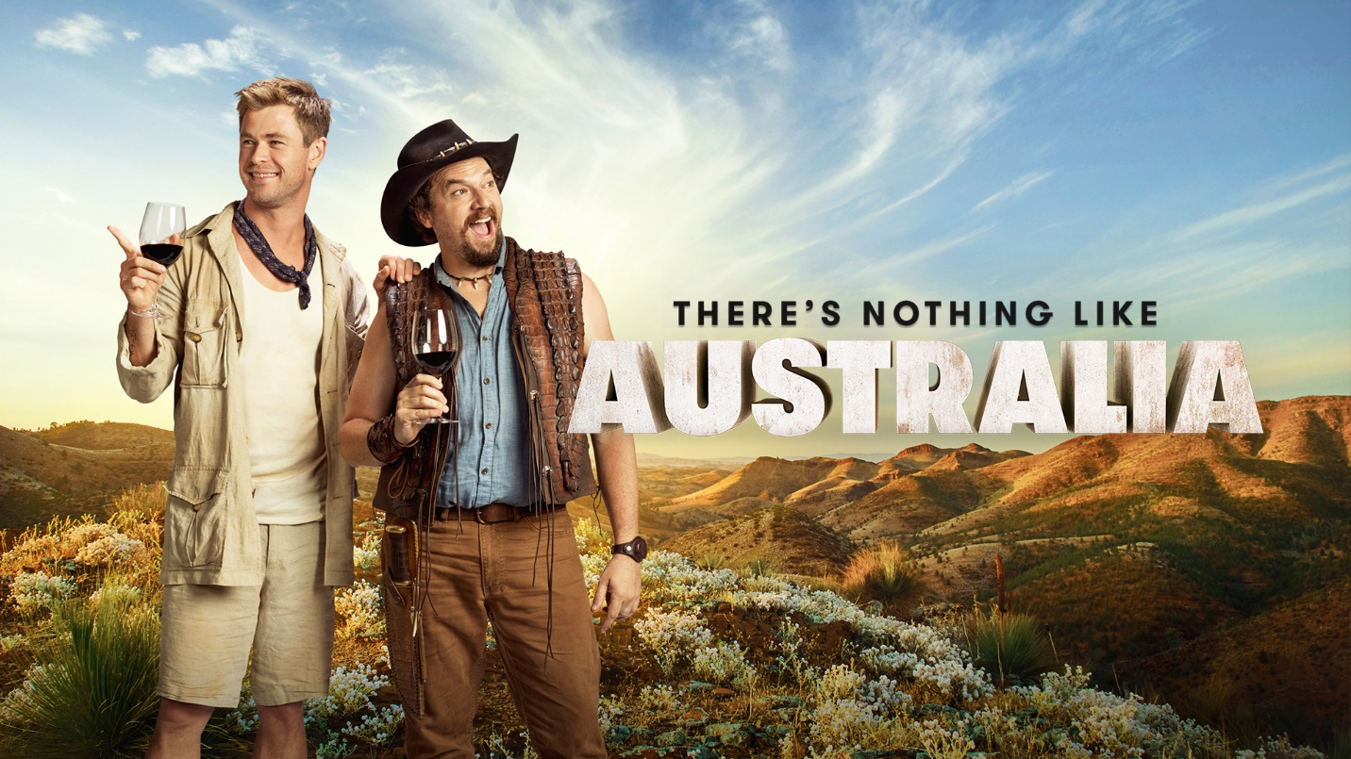
Dundee: The Son of a Legend Returns Home
Tourism Australia plans to make a record investment in the United States (US) over the next 12 months, with a new campaign officially launching in early February 2018. This will be the biggest campaign Tourism Australia has run in the US since Paul Hogan’s Come Say G’Day – released more than 30 years ago – as well as the largest single investment ever made in a single overseas tourism market.
Crocodile Dundee put Australia on the map for Americans, and many other international travellers. Off the back of Paul Hogan’s ‘Come Say G’Day’ campaign, the 1986 film and Mick ‘Crocodile’ Dundee helped shape the American view of Australia and is still relevant today. It showed Americans Australia as a stunningly beautiful country and Australians as friendly and welcoming people.
In 2018, the iconic Australian franchise will return. The original Crocodile Dundee took place in the rugged outback. Its gritty view of Australia helped define America’s view of the country for decades. Australia has changed over the last 30 years, and the campaign reflects that.
The new Dundee will explore a more contemporary version of Australia. Visiting a dazzling array of locations that include the outback, gorgeous mountains, stunning beaches, award‐winning restaurants and wineries.
However, Dundee: The Son of a Legend Returns Home is not a sequel at all. It is actually an elaborate, star‐studded advertising campaign aimed at attracting more travellers to visit Australia. Initially giving the appearance of an official film trailer for a new Crocodile Dundee movie, the 60 second ad cleverly switches into an incredible showcase for Australian tourism.
The 'new' 2018 movie, Dundee: The Son of a Legend Returns Home, was first flagged in mid‐January, with a series of short teaser films taking the form of a traditional studio promotional campaign.
Released through social media, the clips introduced the film's two main characters: Danny McBride playing Brian Dundee, the long‐lost son of Mick Dundee, and Chris Hemsworth as his sidekick, Wally Jr.
A special cameo film featured the rest of the cast with an impressive roll‐call of Hollywood heavyweights and homegrown talent, including Hugh Jackman, Margot Robbie, Russell Crowe, Ruby Rose, Liam Hemsworth, Isla Fisher, Luke Bracey and Jessica Mauboy.
The carefully orchestrated PR and social media campaign encouraged fans to tune in and watch the “official movie trailer" during the Super Bowl (Big Game) where, helped by a cameo appearance by Paul 'Crocodile Dundee' Hogan, Tourism Australia’s new campaign was ultimately revealed.
After the reveal, we have achieved incredible reaction from the audience, especially in the USA. In the US it's been named in the top 6 funniest commercials by USA Today, Top 5 by the Washington Post and a WTF Ad by Rolling Stone.

